NAME: Bathabele Moropyane
Email address: moropyanebathabele@gmail.com
BUIDING A RETAIL DATA AGENT
Introduction and Objectives
The project is about uploading the retail sales dataset in the databricks to build a data agent to enable users to analyse the data using the natural language instead of writing a complete SQL query. The project demonstrates how data can be used to answer business questions and support decisions making.
What is in the Retail sales dataset: The retail sales dataset consists of 9 columns namely customer ID which is the unique number of a customer
2.Sale_date is the date which the sale occurred
3. Transaction_ID is a unique identifier for each sales transaction
4. gender, the customers gender
5.Age, refers to the age of a customer
6.product_category, refers to the category of a product
7.Quantity, refers to the number of units purchased in the transactions
8.price_per_unit, the selling of one unit of the product
9.total_amount, the total value of the transaction

STEP1: UPLOADING DATASET
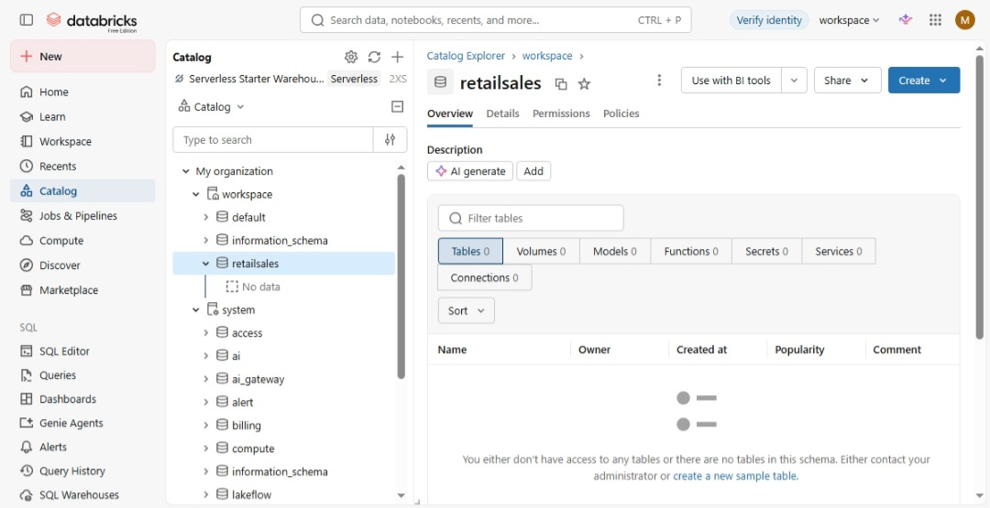

STEP2: REVIEW COLUMNS
The columns that the retail dataset has are; age, customer ID, date, gender, price per unit, product category, quantity, total amount, transaction ID
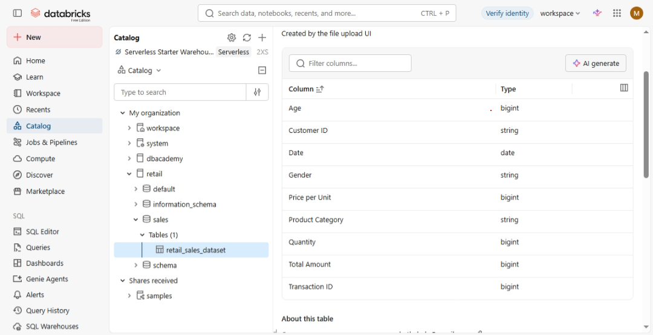
STEP3: PREPARING THE TABLE
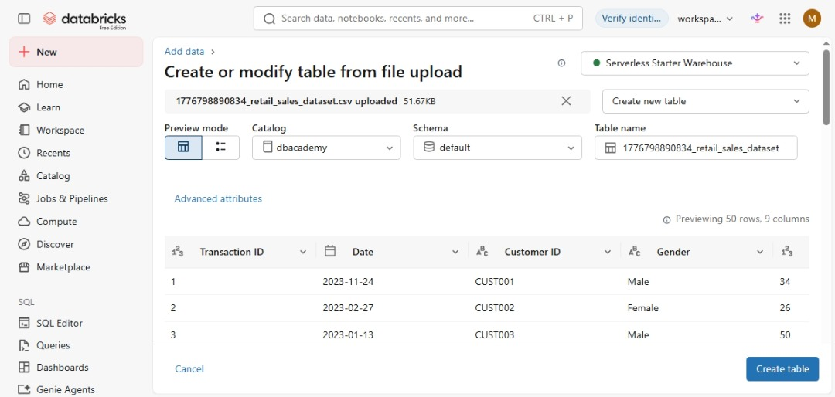

STEP4: CREATING THE DATA AGENT
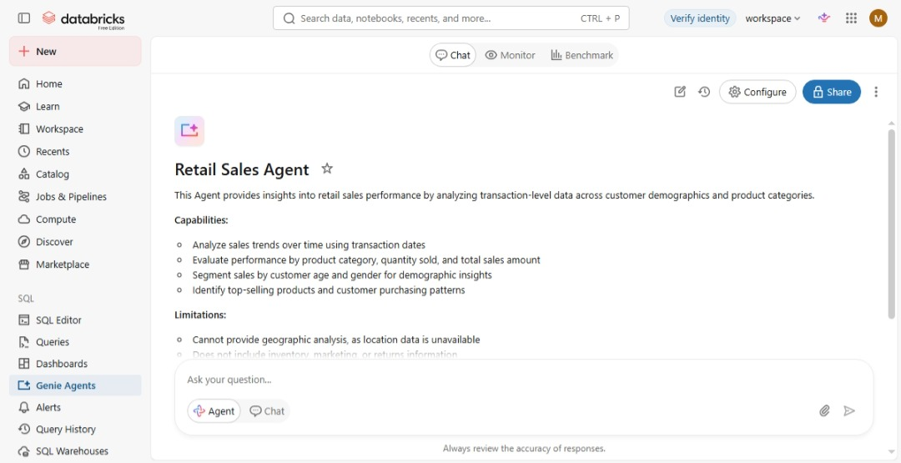

Testing the connectivity
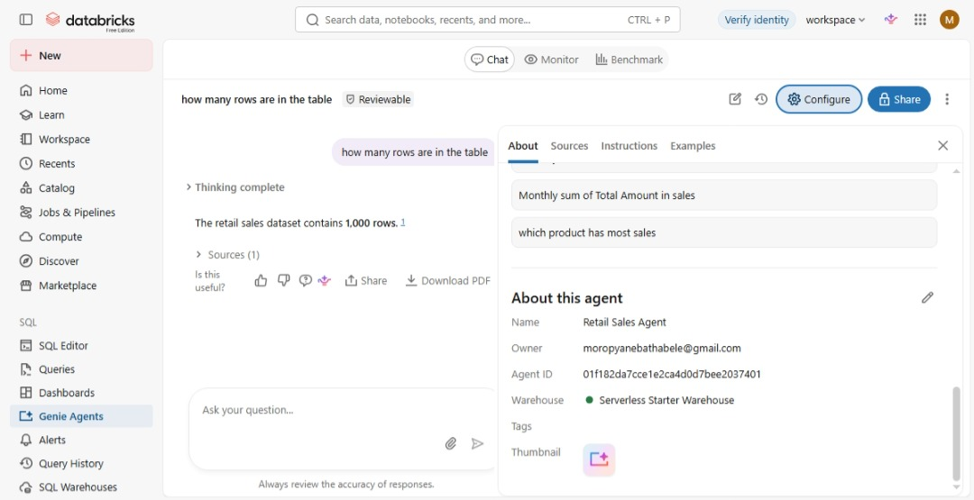

STEP5: INSTRUCTIOS FOR THE RETAIL SALES AGENT
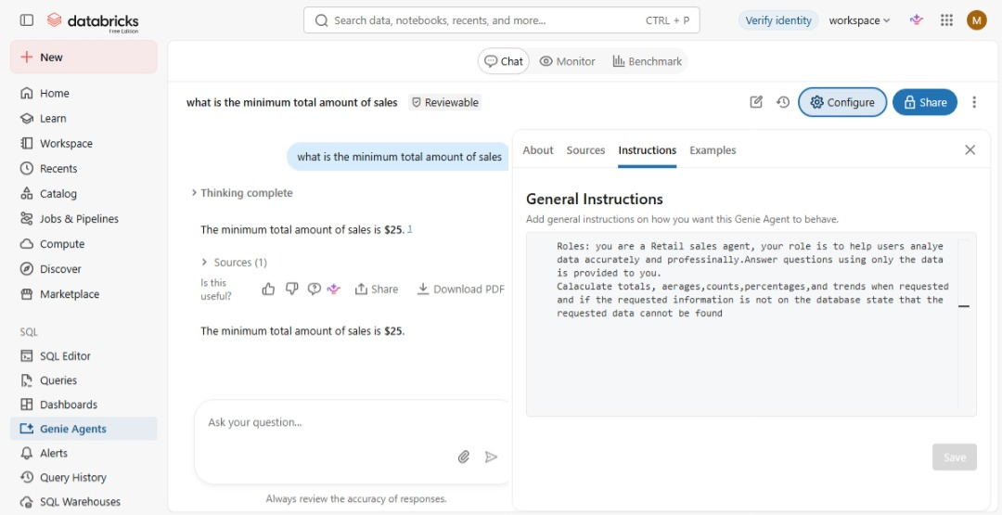

STEP6: TESTING RETAIL SALES WITH 10 QUESTIONS
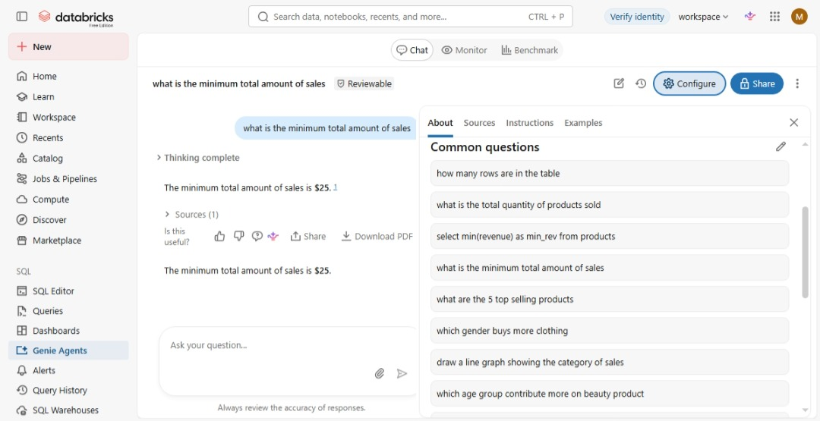
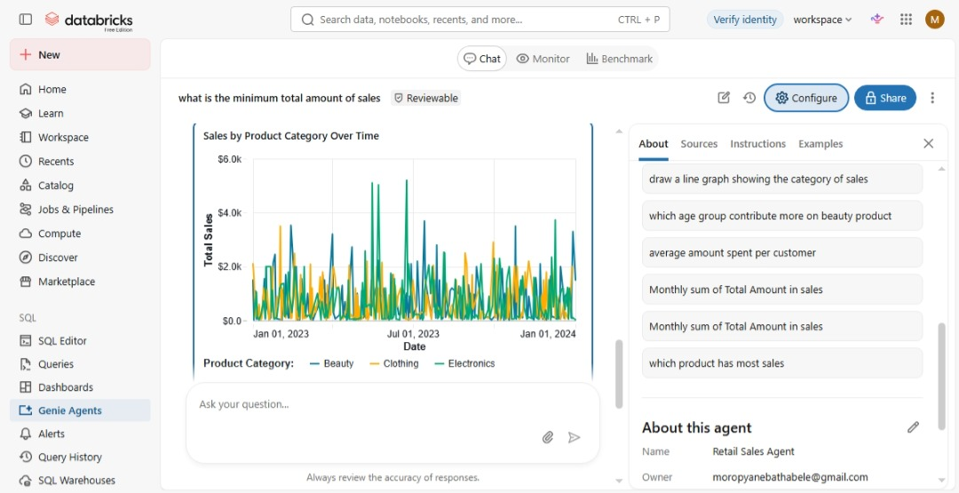

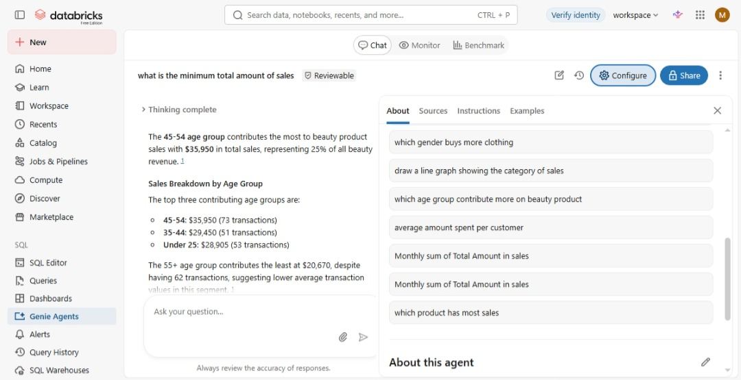
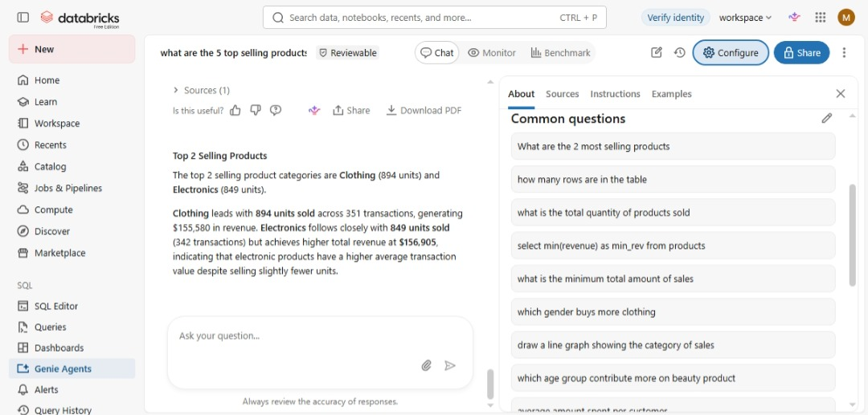
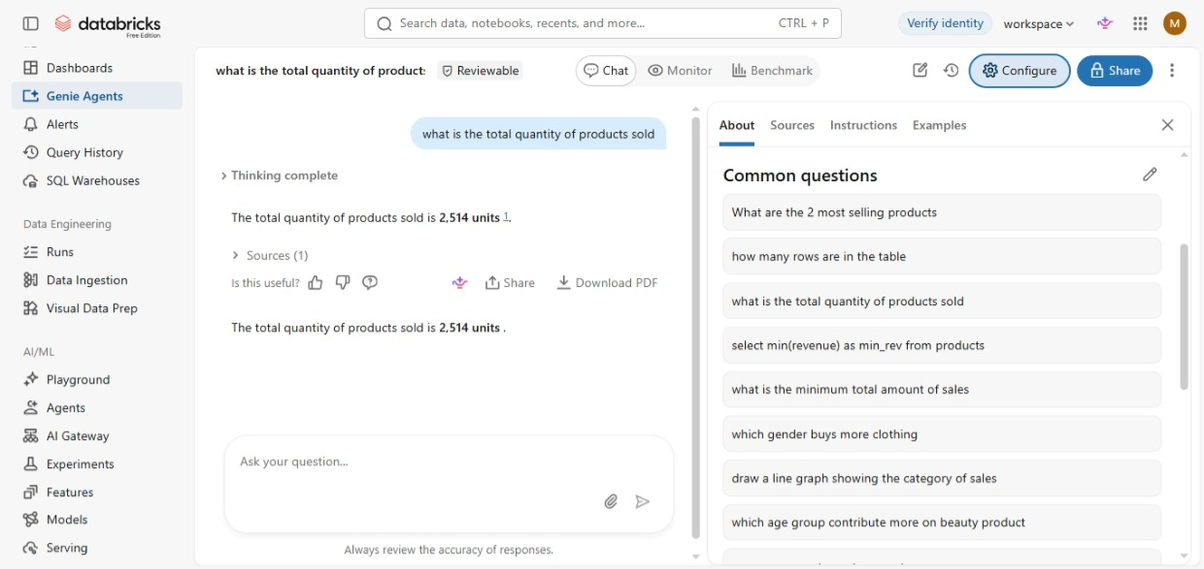
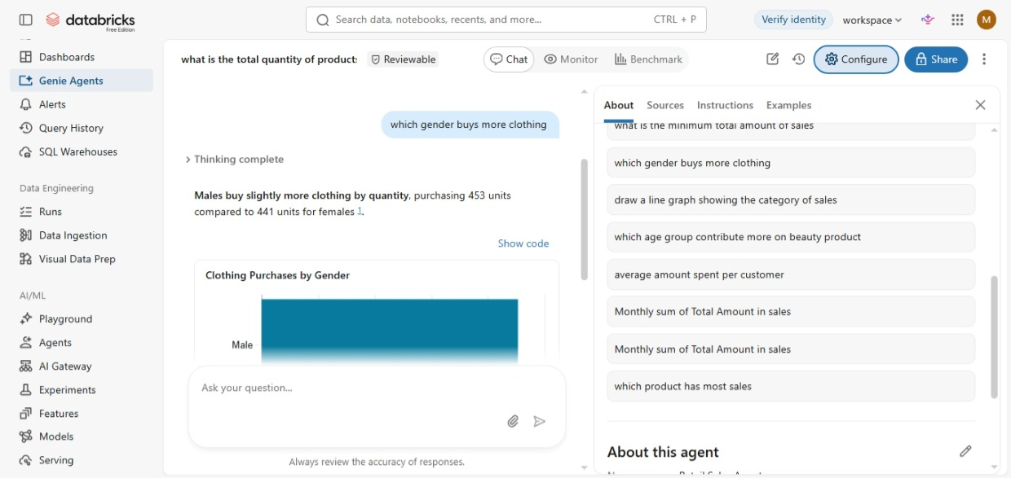
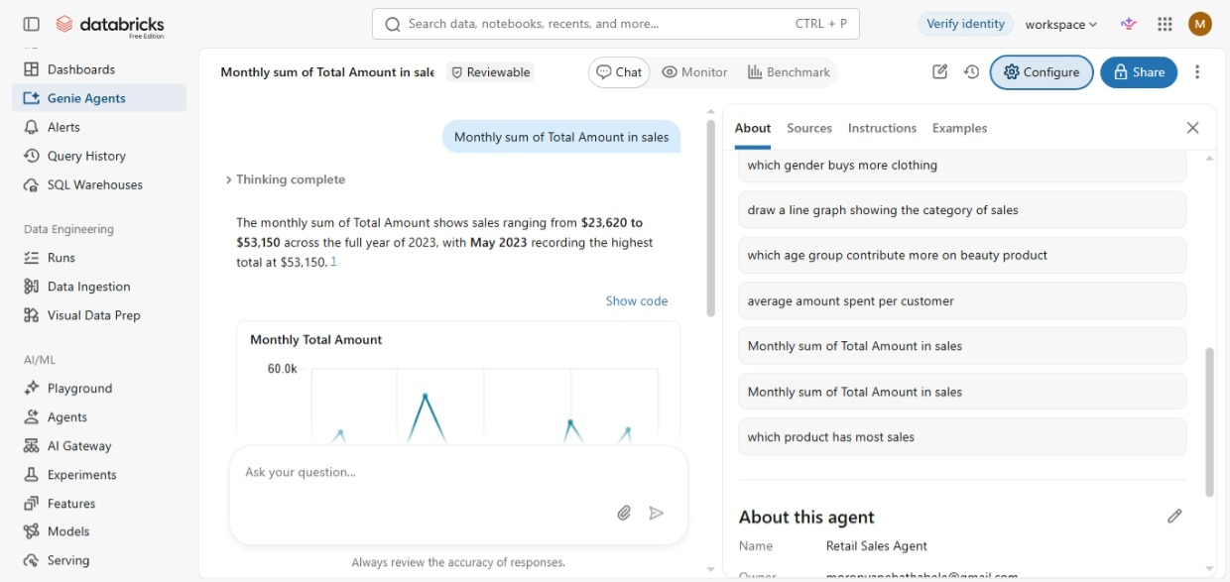
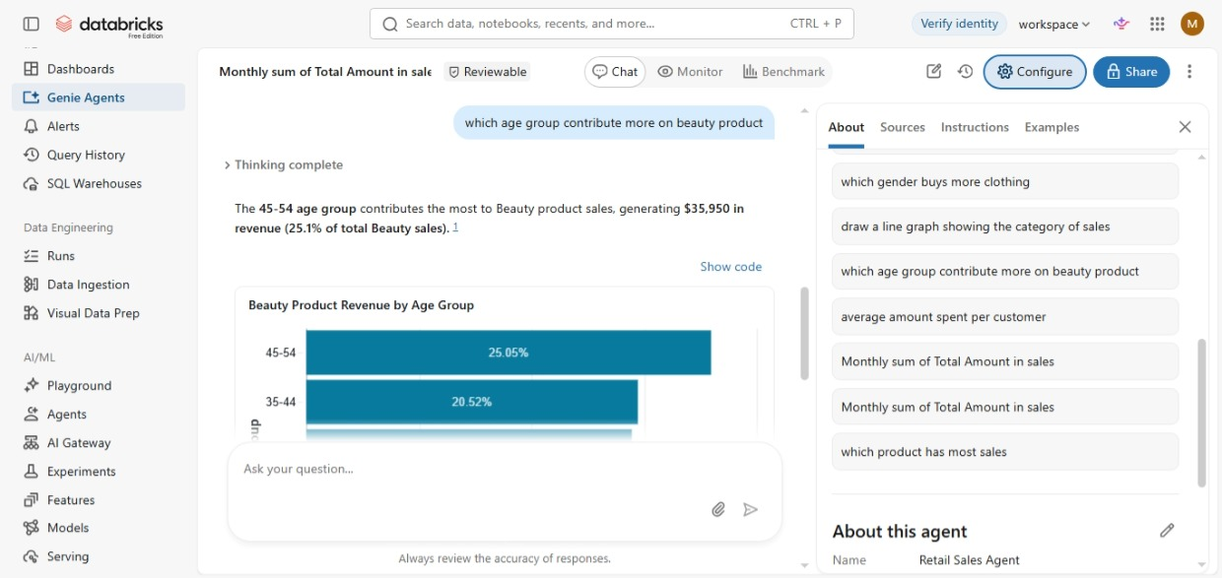
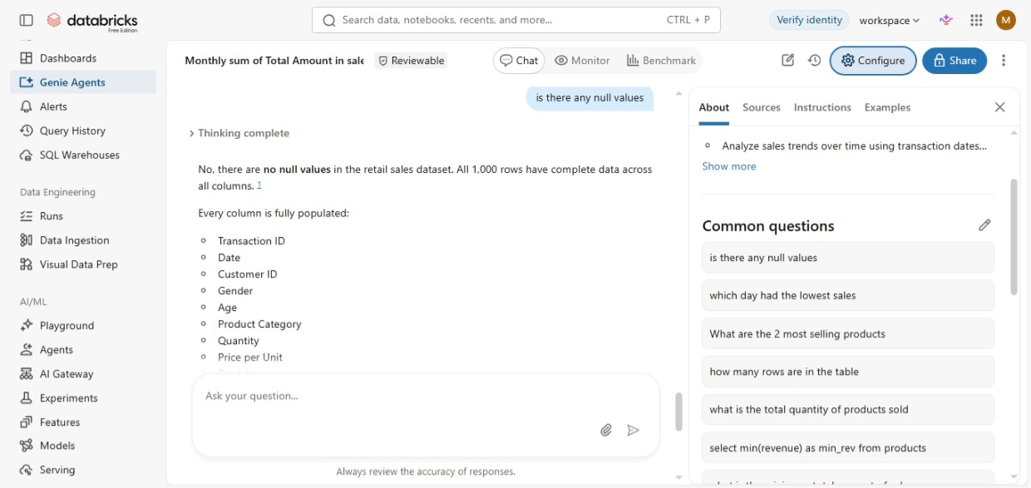

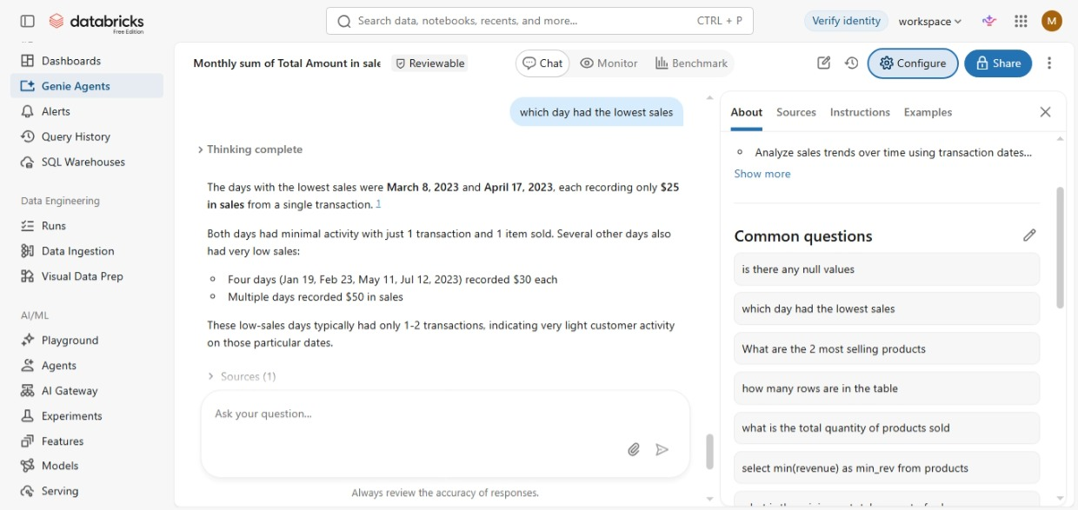
STEP7: VALIDATING THE ANSWERS
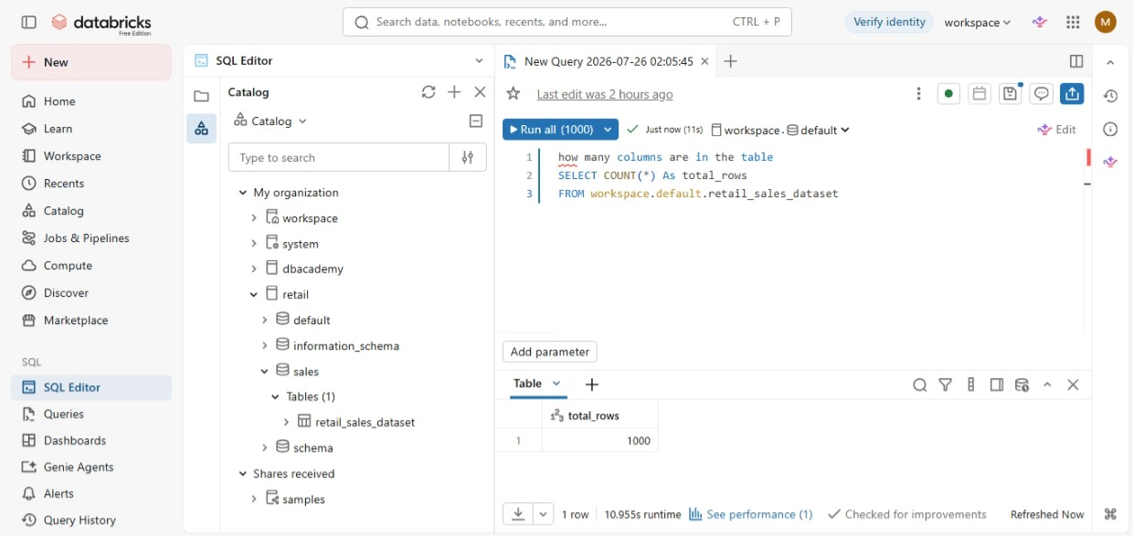

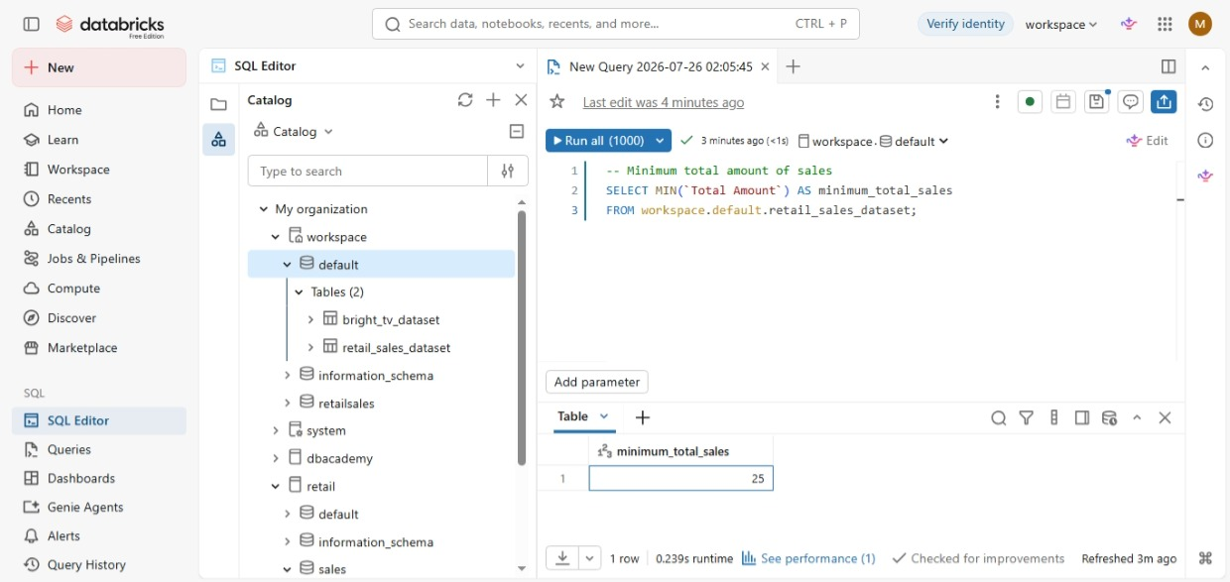

What are the 2 top selling products
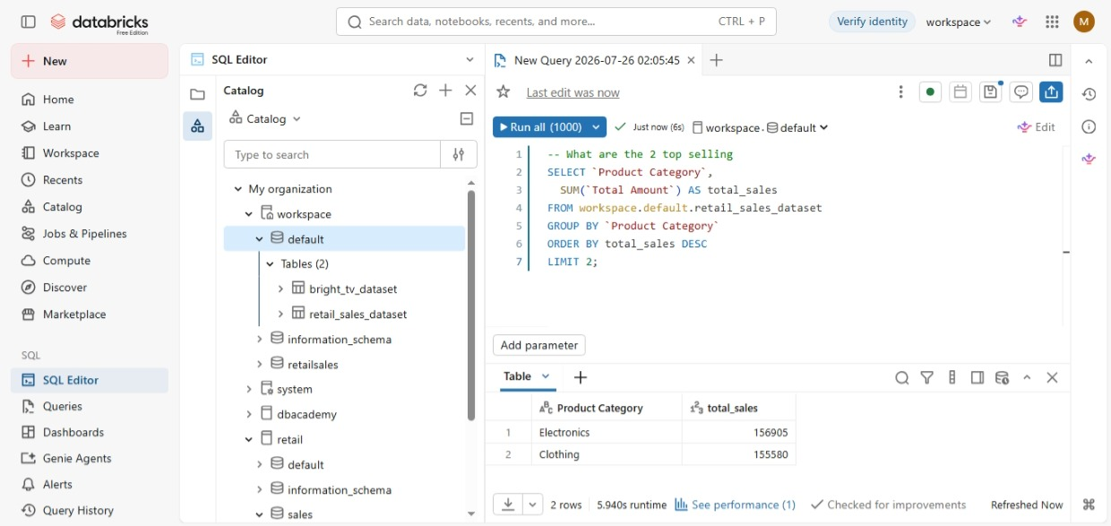

KEY INSIGHTS
Retail sales agent, has revealed that the retail sales dataset has more males purchasing than the females
It also revealed that the shop does not only have the highest sales but it has the lowest sales too, which can help the business improve on the lowest sales by reducing the price or promotions like 3 for 2 to increase sales.
The most purchased product category is clothing and electronics; the shop can stock more of clothing and electronics since they’re the most selling product category
The total number of sales transactions, indicates the overall sales activity

